110770716

Darren Kong

AMS326

Midterm 2

**Problem T2-2:**

This problem was straight forward and simple. The first thing that I created was a function called **f(x, y)**. This takes in two parameters x and y, and returns the value of $x+y+xy$. This is supposed to represent the differential equation $\frac{dy}{dx}=x+y+xy$. The next function is **runge_kutta(f, x0, y0, h)**. The method takes in a function f, which was defined above. It also takes in values x0 and y0 which are the initial values given in the problem, $y\left(0\right)=1$. It also takes in one more parameter h, which is the step size specified, .01. The function approximates the next values for x and y based on the parameters. In other words, the formulas are shown below:

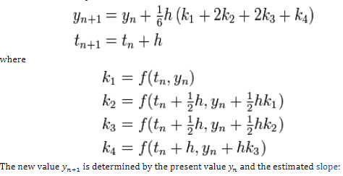

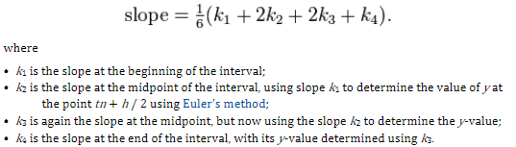

The entire **runge_kutta()** method is thrown into a loop inside a method called problem2. The loop simply records the x and y values generated from each iteration of the runge_kutta method and returns both the x and y values in two respective lists called **xplot** and **yplot** respectively. This is then plotted onto a graph represented by the blue dots.

The next step involves creating the functions **swap_rows(m, i, j)**. This function simply takes a matrix m, and swaps the rows i and j and returns the resultant matrix. This is useful for the next function, which is the **guass_elimination(m)**. The function takes in a matrix m and performs gaussian elimination on it. In other words, swapping rows and doing forward elimination until we have an upper triangular matrix. Then it does a back substitution to get the final answers.

But before we are able to use the guass_elemination function we have to set up the correct matrix. This is where the **create_interpolant_matrix(Ys, Xs)** comes in. The Ys is the y-values for every Xs we chose, i.e. [.1, .2, .3, .4, .5]. It basically creates a matrix in the form below but with the “y” vector merged with the “x” matrix.

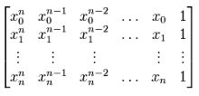

After creating the matrix, we pass it to the **guass_elemination(m)** to get the resultant vector “a”. These will be the coefficients of our polynomial to fit $y\left(x\right)=a_{0}+a_{1}x+a_{2}x^{2}+a_{3}x^{3}+a_{4}x^{4}$. Furthermore, the method **p_x(a_coef, x)** is simply the above equation but returning the value given the parameters. We throw this function into a loop to get the y-values that satisfy the equation above using the same x-values from 0 to .5 with a step size of .01. The resultant y-values are stored in a list called **poly_y.** We plot the values and this gives us the red line shown in the plot. It is a near indistinguishable fit.

